**Indian Knowledge Systems (IKS)**

Solutions to Illustrate Benefits of Indian Knowledge Systems

llustrating the benefits of Indian Knowledge Systems (IKS) involves showcasing their practical applications and advantages in various fields such as health, education, environment, and sustainable development.

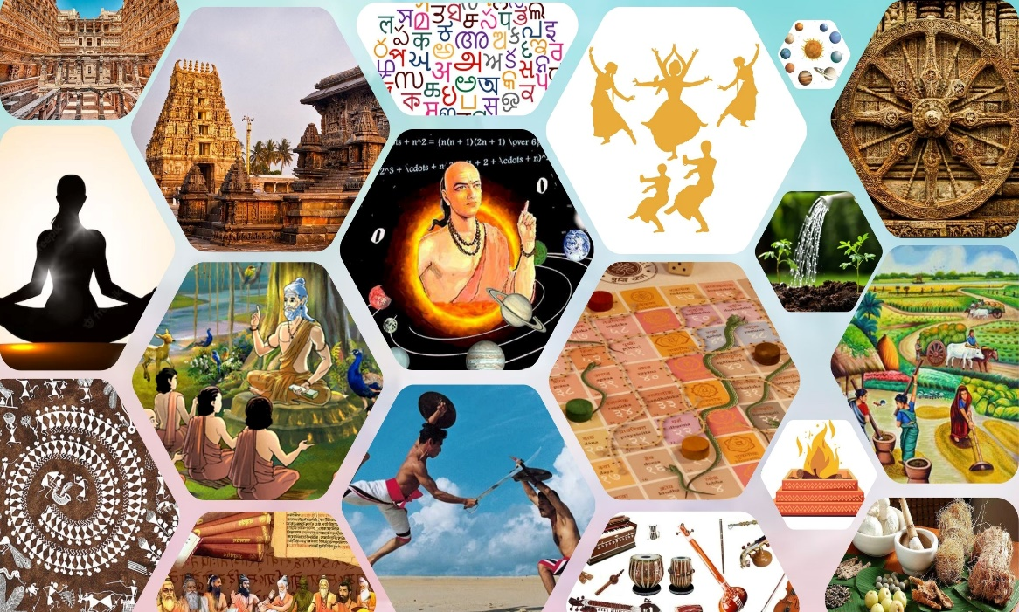

Examples that highlight the benefits of IKS:

* Healthcare & Ayurveda
* Agriculture & Sustainable Farming
* Yoga & Mental Health
* Environmental Conservation
* Education & Pedagogy
* Architecture & Sustainable Living
* Food Nutrition

The solutions for Healthcare & Ayurveda is to integrate of Ayurveda with modern healthcare practices.

The solutions for Agriculture & Sustainable Farming is to promote of traditional agricultural practices and crops.

The solutions for Yoga & Mental Health is to incorporate of yoga and meditation in daily routines and educational curriculums.

The solutions for Environmental Conservation is to revive of traditional water management systems.

The solutions for Education & Pedagogy is to integrate of traditional knowledge and languages into modern education.

The solutions for Architecture & Sustainable Living is to use of traditional building materials and techniques.

The solutions for Food Nutrition is to promote of traditional diets and local superfoods.

Indian Knowledge Systems offer valuable insights and solutions that are not only culturally significant but also highly practical in addressing modern challenges. By integrating these traditional practices with contemporary knowledge, we can create sustainable, efficient, and holistic solutions that benefit society and the environment.